NIIT UNIVERSITY

FEASIBILTY ANALYSIS
for
“SHARE KARO APP”
2016-17

17 September’ 2016

Submitted To: Submitted By:
Prof. Amit Kumar Ayushi Jain
U101114FCS055

TABLE OF CONTENTS

- Executive summary……………………………………………….....

- Description of products and services……………………………..

- Seeding Survey…………………………………………………………

- Technology Considerations………………………………………….

- Product and Service Marketplace………………………………….

- Threats…………………………………………………………………..

- Marketing……………………………………………………………….

- Findings and recommendations……………………………………

- Conclusions…………………………………………………………….

- References………………………………………………………………

EXECUTIVE SUMMARY

“Share Karo” App has been designed as a Vth Semester software engineering project. The project has been developed by Akshay Gupta: U101114FCS039 (S2), Anshul Sharma: U101114FCS046 (S2), Ayushi Jain: U101114FCS055 (S2), Ishtaa Sayal: U101114FCS070 (S3), Jatin Kakkar: U101114FCS072 (S3) and Jharana Shrivastava: U101114FCS073 (S3).
The admin rights of the application and the first installment presentation lies with the developers and founders of this app. The application is completely developed by the founding members with proper division of workforce. 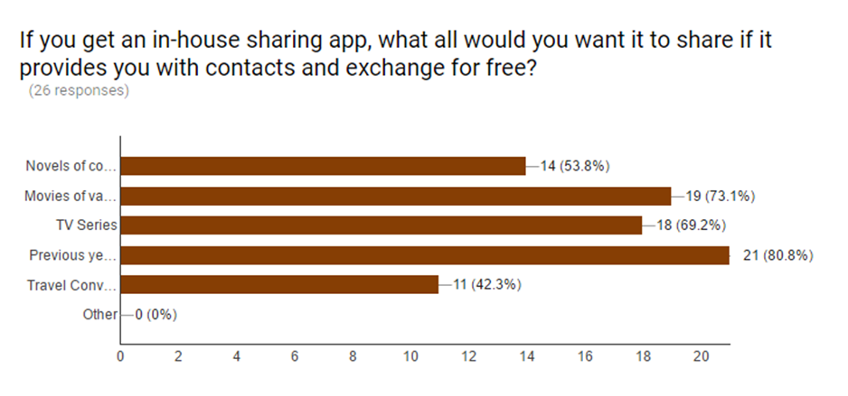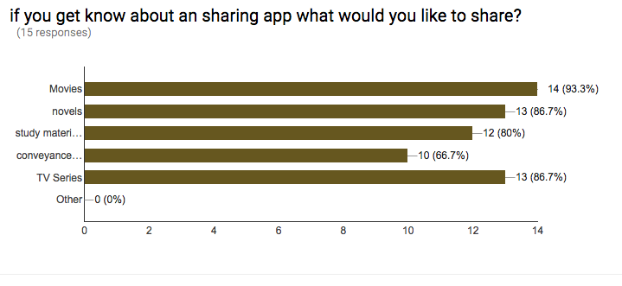

DESCRIPTION OF PRODUCTS AND SERVICES

The main feature of the project includes

Movie Sharing:

Students spend a lot of their leisure time by indulging into movies. This is one of the most wanted and prioritized feature of this app. Users can update their collection and search for movies they would like to watch.

Novel Sharing:
Reading is one of the best and most addictive hobbies. We put this feature on our priority list based on the fact that book eaters will not only be willing to share their novels but also acquire novels from any source. They would be more than willing to update their collection and look for novels through our app.

TV-Series Sharing:

TV Series is again a highly preferred mode of entertainment. Due to restrictions to certain websites and constraints with downloading heavy content through internet, student often feel the need to get these series through a better and more feasible source and therefore we kept this feature in our priority list. Students can share and acquire TV series very easily through this application.
Study Material Sharing:

The app will be a great platform to share any kind of study material that they no longer need or are willing to share. Students can look for the study materials like presentations, project etc for a specific course.
Conveyance Sharing:
Students prefer to share a cab to a common destination in order to reduce the travel cost. It’s again put up in a low priority level of the app. Students can put their travel details like date and time of journey and destination and search for the users travelling around same time. This would provide them with a option to share the conveyance.

SEEDING SURVEYS

It is very important to judge the target audience and their interest in any developing project. Surveys are the best way to judge whether the services that the app provides are after all needed or not. Will students prefer using this product or not or whether they have some feedback on the same. It not only increases the quality of the products but also highlights all the shortcomings and hence the team chose to conduct a survey.
Since this product fundamentally targets college students and has been designed keeping their best interests in mind, the team conducted a survey within the college campus. After the survey, it has been observed that hostellers tend to look out for sharable movies, novels and TV series to watch for entertainment in the leisure time in hostel.
Through surveys have been conducted on college/university students and the results have led to development of the project. Two kinds of surveys have been conducted.
One of the surveys was done to know whether the idea is feasible or not? This is the Seeding idea survey.
Another survey was done to know the response of the students towards the app, weather they are going to use it or not.
Here is the link for the seeding:
https://docs.google.com/a/st.niituniversity.in/forms/d/e/1FAIpQLSdQRok8juXlh7KKhXiNcEUZWWn9YxTKTtLWmKertD9MFtg0fA/viewform

Responses:
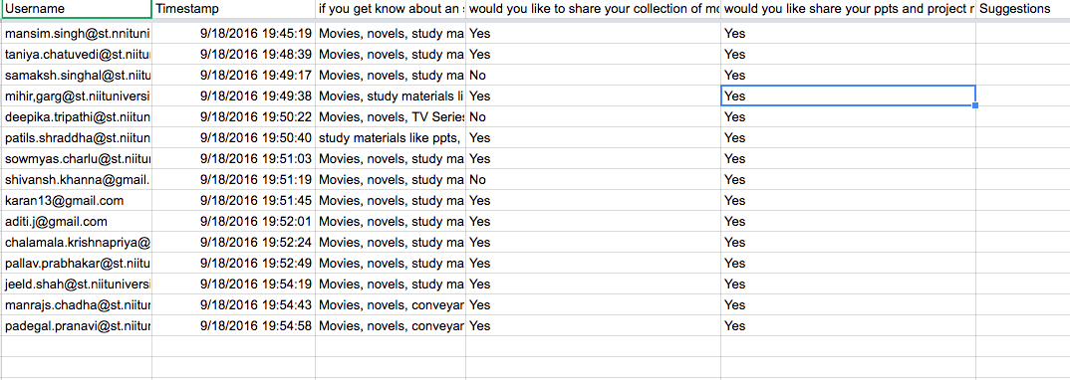
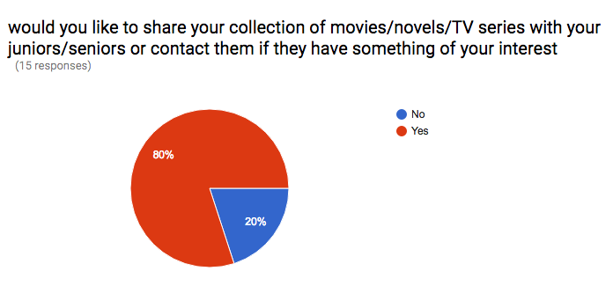
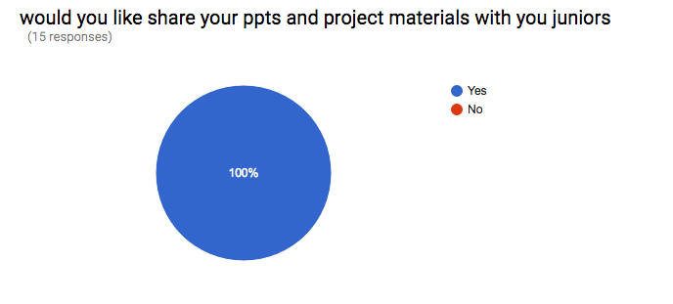
TECHNOLOGY CONSIDERATIONS

Definition of following frameworks has been used to build this software:
Definition of following frameworks has been used to build this software:
- To design the database framework, we chose to use Mongo DB framework.
- HTML, CSS, Java Script, Node js are built on Visual code 2015 enterprise software.
- The end product will be compatible with all major operating systems.
- Node JS framework is as follows: Integration with other Visual Studio features and 3rd party tools. (Node.js, io.js, JavaScript, TypeScript, HTML, CSS, and JSON support)

Heavy or complicated software is not required in build up of this software. Minimal requirements have been there for build up of this software.

PRODUCT/SERVICE MARKETPLACE

Though the software has been designed for university students. However, it can be generalized and extented to local areas where physical contact between people is feasible.
Here are the responses that have been recorded for the surveys:
Survey form link:
https://docs.google.com/a/st.niituniversity.in/forms/d/e/1FAIpQLSdQRok8juXlh7KKhXiNcEUZWWn9YxTKTtLWmKertD9MFtg0fA/viewform

THREATS

The project idea could face serious oppositions or failures if the following conditions are somehow invalidated:
- The people are not willing to share their private collections.
- People are not willing tp interact with new people or socialize
- The physical contact is not possible between people.
- The people don’t sign up or update data on the concerned forum and don’t make it visible.
The threats are taken care of in the manner where the app is made completely interactive and lucid for usage. It is considered that students are generally open to socializing and procuring their needed stuff from sources.

MARKETING STRATEGY

The marketing strategy includes promoting the project on various social media platforms such as Facebook, Google+, Snapchat,etc.
The product will be promotes on campus with the help of flex banners and posters. The website will be available on all official University Profiles.

FINDINGS AND RECOMMENDATIONS

The Application has received a great response from majority of the people. It is likely to create a breakthrough as a sharing application.
The app is highly recommended for anybody who wishes to share stuff and reduce upon the costs while doing so.

CONCLUSIONS

The “Share Karo” application is perfectly fine to go for the designing and development phase.
The application comes with advantages listed below:
- Low memory requirements for database and size of software.
- Cross platform application.
- Open source functioning to invite other developers to contribute after the completion of college project.
- Simple User friendly interface with latest guidelines in market.
- Privacy protection for the users.
- Simple interaction and exchange of things between users.

REFERENCES
- https://www.google.co.in/search?q=feasibility+analysis+pdf&oq=feas&aqs=chrome.1.69i59l3j69i57j0l2.3767j0j7&sourceid=chrome&ie=UTF-8
- http://thenextweb.com/apps/2015/07/10/9-of-the-best-apps-for-sharing-files-between-devices-and-friends/
- https://www.google.co.in/forms/about/
- https://teamtreehouse.com/tracks/front-end-web-development
http://www.inc.com/murray-newlands/15-marketing-strategies-that-inspire-strategic-thinkers.html

